

BACHELOR OF SCIENCE COMPUTING COMP1787 REQUIREMENTS MANAGEMENT

Name: Nguyễn Châu Hữu Khang

Reg No: 001391467

Department: SCIENCE COMPUTING

Coursework name: Requirements management

Course code: COMP 1787

Submission date: 30/03/2024

Email ID: khangnchgcs210066@fpt.edu.vn

**DUE DATE: 26 APRIL 2021**

**WORD COUNT: 7,952**

# Table of Contents

Table of Contents 1

Table of Figures 2

Section – A 3

1. Introduction about Online Geen Groceries Platform 3

2. Drawbacks of Traditional Software Development Methodology 3

3. Agile Framework Methods and its Overview 4

3.1 Prototyping 4

3.2 Joint Application Development (JAD) and Facilitated Workshops 5

3.3 Timeboxing 5

3.4 Facilitated Workshop 5

3.5 Scrum 6

3.6 DSDM approach 6

4. Systematic Workflow of Green Groceries Online platform done with Agile Method 7

4.1 Development Team Structure and Roles 7

4.2 Scrum Meetings 7

4.3 Architecture Diagram of the Green Platform 8

4.4 Project Structure and Completion 9

5. Merits of Using Agile Concepts 14

Section B 15

High-Level Requirement Analysis using MOSCOW rules 15

B1. Baseline Requirement Review 15

B1.1 -> Given Requirement Analysis using MOSCOW rules 15

B1.2 -> Updated High-Level Requirements 17

B2. Timebox Rules for the Updated High-Level Functional Requirements 17

B2.1 -> Prioritization for the List of Requirements 17

B2.2 -> Explanation about Prioritizing the Requirements and the Decisions taken to the Green Groceries Online Platform 18

Section C 19

Legal, Social, Ethical, and Professional Issues 19

C1. Legal, Social, Ethical, and Professional Issues (LSEPI) 19

C2. Purpose of a Professional Body and the BCS Code of Conduct 21

Conclusion and Assumptions 23

REFERENCES 25

# Table of Figures

Figure 1: Unoptimized mobile UI 4

Figure 2: Architecture Diagram of the Green Platform 8

Figure 3: Sprint 2 DFD of Customer Account Management and Security Module 9

Figure 4: Sprint 3 DFD of Product Catalog and Shopping Cart Module 10

Figure 5: Sprint 4 DFD of Checkout Process and Payment Module 11

Figure 6: Sprint 5 DFD of Order Management Module 12

Requirement Management Report for the Case Study “Geen Groceries Online Platform”

# Section – A

## Introduction about Online Geen Groceries Platform

- The Online Green Groceries platform was created by Green Groceries, a company known for its organic and locally produced items. They hope to broaden market reach and make sustainable products more accessible by introducing this platform. Due to previous issues with traditional projects, the company outsources its software projects and has selected System Concepts to develop the platform utilizing Agile methodologies. The collaboration intends to build a robust platform that reflects the company's ideals of sustainability and accessibility while overcoming historical issues with flexibility and responsiveness.

## Drawbacks of Traditional Software Development Methodology

- The website https://greengrocery.com.bd, designed to simplify grocery shopping for various items, had several significant challenges, particularly among mobile users. Mobile commerce is now necessary; thus, optimizing the website's mobile interface raises several essential concerns. Scaling, navigation, and load times are issues that users require help with. These obstacles hamper user experience and may hurt the company's bottom line. These issues are crucial since most customers now use their phones to shop online. Due to this, mobile-first methods and responsive site designs are essential to assure user accessibility and satisfaction. These issues must be addressed to maintain a competitive edge and meet changing consumer needs.

- One of the examples of unoptimized website development in <https://greengrocery.com.bd> with the web mobile interface. Unlike the desktop version of the web, the mobile version could be better optimized for the user experience. The most confronting element is that the size of the box containing product information needs to be resized for the lower resolution of the mobile phone. The result is that the mobile user can only view 1 product at a time and has to scroll up if they want to browse more products constantly. Moreover, on the product page, the page select option only exists at the bottom of the page; mobile users have to scroll to the last of the page. These significant inconvenience UI elements may result in user frustration while experiencing the website.

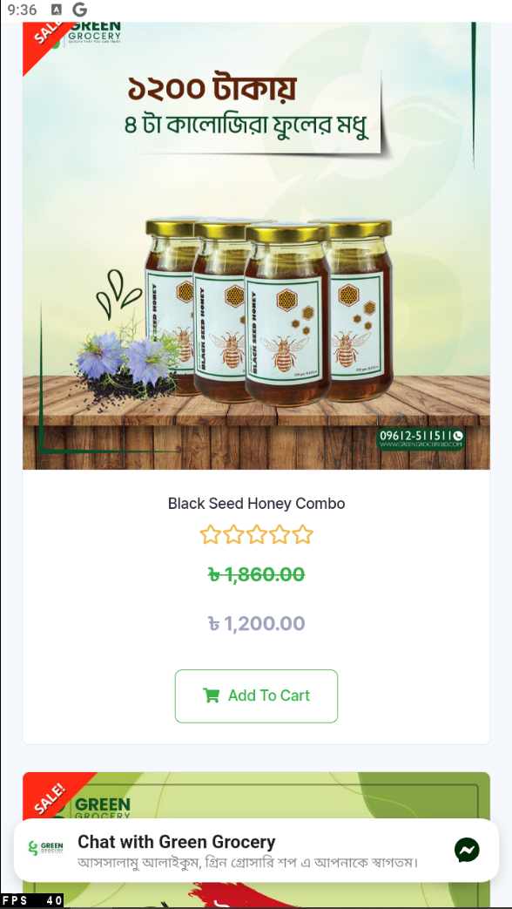

Figure 1: Unoptimized mobile UI

- Furthermore, the problems identified in the mobile interface of greengrocery.com.bd highlight the limitations of conventional web development methods, such as the waterfall model. The waterfall paradigm involves sequential development, with each step relying on the previous one. This strategy often lengthens development timelines and reduces flexibility. Websites developed using the waterfall method may overlook user experience improvements like mobile friendliness. The inadequate mobile experience of greengrocery.com.bd shows how late responses to user needs and technical advances can lead to undesirable results. Therefore, agile and iterative development methodologies can eliminate these issues and improve user experiences across platforms and devices.

>>Bullet Points Of Water Fall Model Drawbacks

## Agile Framework Methods and its Overview

- Facilitated Workshops, Prototyping, the Timebox approach, Joint Application Development (JAD), Sprints and Scrums, and the Dynamic Systems Development Method (DSDM) are some of the methodologies that are necessary for the development and implementation of the online platform for Green Groceries on time that is also completely effective.

### 3.1 Prototyping

- Iterative prototyping builds experimental systems quickly and cheaply for demonstration and assessment. This is "prototyping". This technique uses a functional system model early in development to help clients assess their information needs. Traditional systems analysis takes too long to determine system functionality and user needs. A growing prototype could become the final system, or a trash prototype could be used to build the new system. Both options are feasible. Both options are viable.

- Prototyping will be used to quickly construct trial versions of the web platform iteratively. Because of this, Green Grocery will be able to respond rapidly to user feedback and promptly iterate to improve features and needs. The business needs a flexible development process to adjust to shifting demands and guarantee that the finished product satisfies the industry's and client's needs. This approach meets the needs of the company for this kind of procedure.

### 3.2 Joint Application Development (JAD) and Facilitated Workshops

- Project managers, sponsors, information system experts, and essential end users collaborate in organized meetings throughout the planning and development of systems. JAD and facilitated workshops are applicable in this setting. Goal-setting to get agreement among stakeholders on the project's scope and high-level demands is the most crucial goal. These meetings are essential because they enable user knowledge, remove organizational barriers, and ensure that management direction and user feedback are integrated into the development process.

- Green Grocery and the System Concepts development team stakeholders will participate in cooperative sessions using Joint Application Development (JAD) and Facilitated Workshops. By defining and improving the project requirements, scope, and design during these sessions, it is anticipated that all perspectives will be heard and a decision will be made regarding the course of the website development.

### 3.3 Timeboxing

- The project management method known as "timeboxing" prioritizes product-based viewpoints above activity-based perspectives by setting deadlines (timeboxes) for delivering particular system components. This approach encourages incremental delivery instead of releasing the entire system at once by creating and providing each functional element in the system one after the other within predetermined timeframes. When effectively managing expectations and resources, timeboxing is used with the MoSCoW recommendations for job prioritizing in development to guarantee that critical features are delivered first.

- To effectively manage project schedules, the Timebox method will be applied in which projects are broken down into fixed timeframes within which specific functionalities must be provided. This method ensures that, in line with the priority requirements of green grocery stores, the project is carried out on time and focuses first on delivering the most essential elements.

### 3.4 Facilitated Workshop

- Regarding the Rapid Application Development (RAD) methodology, the technique known as the Facilitated Workshop is an essential component. This technique focuses on collaborative and interactive sessions that involve crucial project stakeholders. The presentation provides further information about this technique. These workshops implement a structured and supported process to promote the rapid convergence of high-level requirements, project scope, and design decisions.

- Using a Facilitated Workshop can considerably accelerate the development process and ensure that the project is aligned with the company's beliefs and objectives, as demonstrated by the case study of Green Groceries, which aims to build an online platform. This method may help address the issues and requirements identified by Green Groceries and System Concepts professionals.

### 3.5 Scrum

- In the context of the Green Groceries online platform development project, which is discussed in the case study, System Concepts uses Scrum, an essential component of the Agile methodology, to manage and structure the software development process in a manner that is efficient and adaptable.

* **Scrum:** Scrum promotes teamwork, responsibility, and iterative progress toward a stated objective in Agile software development. Scrum helps team members solve challenging challenges and produce high-value products creatively and productively.
* **Sprints:** Sprints, which are time-boxed periods during which particular work must be done and made ready for review, are the backbone of the Scrum framework. Sprints make up the essential components of the framework.

### 3.6 DSDM approach

- An Agile project delivery framework that emphasizes strategic alignment and business impact is DSDM Atern, now known as DSDM (Dynamic Systems Development Method). Through governance and accountability, stakeholder participation, quality focus, and iterative and incremental development, the eight principles of DSDM strive to generate strategically aligned business advantages in a short amount of time:

* **Business Need:** Green Groceries wants to increase its market reach and provide more sustainable products online. Green Groceries benefits from the project since the DSDM strategy relates every decision and development step to this business aim.
* **Deliver on Time:** DSDM prioritizes project timelines. Green Groceries plans a three-month online debut. DSDM organizes work into fixed-length iterations (timeboxes) to keep the project on an ambitious timeframe.
* **Never Compromise Quality:** DSDM sets quality criteria from the start, and all deliverables must fulfill them. This requires making the Green Groceries online platform secure, user-friendly, and able to handle expected traffic growth without performance deterioration.
* **Demonstrate Control:** DSDM organizes project responsibilities, decisions, and progress. This systematic approach keeps the project focused on Green Groceries' strategic web platform.

## Systematic Workflow of Green Groceries Online platform done with Agile Method

- In the Green Groceries Online Platform project, they use certain techniques. Their website projects involve planning, gathering requirements, and implementing phases within each sprint. The team stays organized by tracking progress and addressing issues during sprint planning sessions and regular stand-up meetings. Key Agile concepts, like sprint reviews and retrospectives, create a feedback loop that allows for adjustments and enhancements throughout the development cycle. By adopting this approach involving stakeholders from Green Groceries and System Concepts, they ensure a shared vision and commitment to success, leading to an innovative e-commerce development process.

### 4**.1 Development Team Structure and Roles**

- The development team from System Concepts that is working on the Green Groceries project is comprised of a variety of occupations, each of which contributes to a distinct module of the project:

* **Millie:** Millie is a trained programmer who specializes in web development. Due to her knowledge and her ability to communicate effectively, she is likely to participate in all sprints.
* **Peter:** Peter is an experienced web developer who, although having periodic disagreements with clients, may be able to contribute to the key development activities that are being completed across sprint groups.
* **Anita:** Strong in web development, Anita is likely to contribute across various modules, particularly ones that require inventive solutions.
* **Cheryl:** The team is led by Cheryl, who is responsible for monitoring the Agile development process for the project and ensuring that milestones are fulfilled across all sprints.
* **Pat:** Pat is a part-time contributor focusing on web development and testing. He is most likely active in the final sprints focused on performing testing and getting ready for launch.

### 4.2 Scrum Meetings

- Scrum meetings, an essential component of Agile techniques, would be utilized to guarantee proper alignment and adaptability throughout the Green Groceries project. For the most part, these discussions would focus on:

* **Daily Stand-ups**: To ensure that each sprint remains on track, daily stand-ups are brief meetings to discuss progress, impediments, and immediate goals.
* **Sprint Planning**: The process of establishing the goals of each sprint and the actions that must be completed to reach those goals is referred to as "sprint planning."
* **Sprint Reviews:** After each sprint, review the work performed and make any necessary adjustments to the product backlog based on the input received.
* **Sprint Retrospectives**: Sprint retrospectives are discussions after each sprint review, during which it is discussed what went well, what may be improved, and how these improvements can be implemented in the subsequent sprint.

### 4.3 Architecture Diagram of the Green Platform

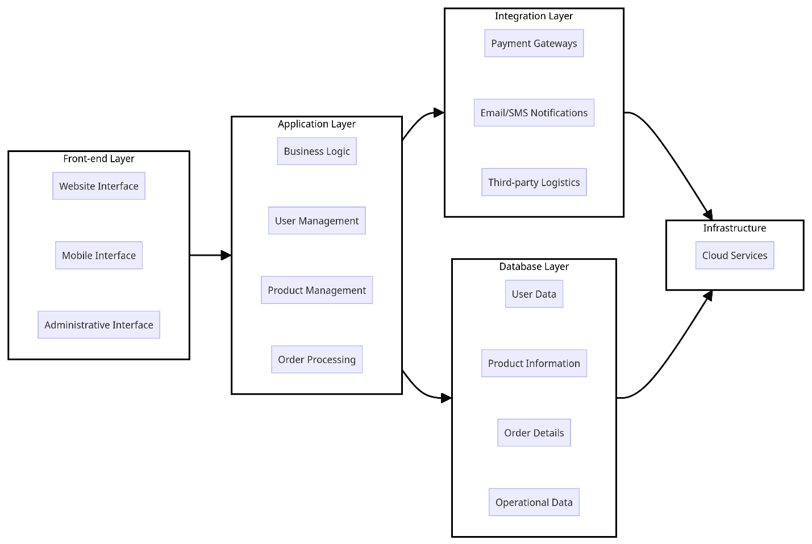

Figure 2: Architecture Diagram of the Green Platform

- Architecture Diagram of the Green Platform evaluation:

* **Front-end Layer** (User Interface): This layer will assist with easy navigation for consumers and staff, including functionality for account administration, adjustments to shopping carts, order processing, and distinctive elements such as a virtual celebration for the CEO's birthday. It was designed with usability and accessibility in mind.
* **Back-end Layer** (Server-side): The application logic, database management for user information, order processing, and inventory management will all be included in this layer. It will ensure compliance with data protection regulations, handle peak traffic using scalability solutions, and encrypt user data to provide privacy and security.
* **Integration Layer**: Facilitates communication between the front-end and back-end layers, including payment gateways, delivery slot management, and external application programming interfaces (APIs) for additional services (such as VAT compliance tools).
* **Infrastructure**: To manage the anticipated thirty percent increase in traffic during peak periods, robust servers and cloud services intended for high availability and scalability are required.

### 4.4 Project Structure and Completion

- The Green Groceries project is organized in line with Agile methodologies, specifically Scrum, and can be divided into six sprints over three months. Each sprint lasts two weeks, and there are particular objectives and deliverables.

**Sprint 1: Initialization and Planning**

* **Activities**: Setting up development environments, establishing Agile workflows, and prioritizing the product backlog with a focus on core functions essential for the MVP are the activities that must be completed.
* **Key Deliverables:** Project plan, product backlog for development, and initial architectural design.
* **Daily Meeting Focus:**
* *Update:* Cheryl summarizes the progress made on the Agile process setup and backlog prioritizing to provide an update. Millie, Peter, and Anita discuss the architectural design and let each other know how far along they are.
* *Challenges:* Discuss any challenges encountered in establishing development environments or achieving alignment on the initial architectural design required.
* *Next Steps:* Millie will complete the preliminary architectural blueprints during the following steps. If there are any problems with the setup, Peter and Anita will be there to help.

**Sprint 2: Customer Account Management and Security Module**

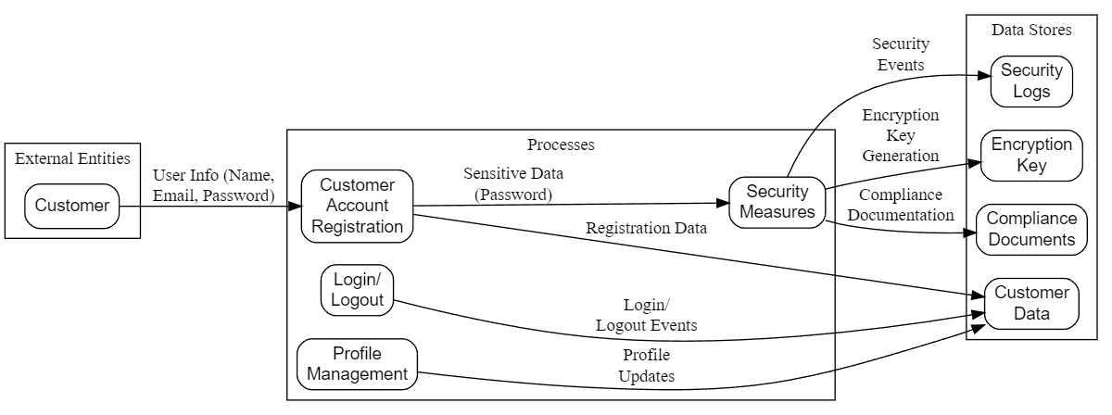

Figure 3: Sprint 2 DFD of Customer Account Management and Security Module

* **Activities**: The activities include developing capabilities for registering client accounts, logging and logging out, and managing profiles. Immediately begin the essential work on security measures, consisting of data encryption and compliance with data protection legislation.
* **Key Deliverables:** Customer account management system, basic security foundation.
* **Daily Meeting Focus:**
* *Update:* Millie has provided an update on the progress that has been made in the development of client account management tools. Peter discusses the progress made in putting security measures into place. Anita supports both of these elements.
* *Challenges:* Determine whether there are any concerns with compliance or technological difficulties in data encryption.
* *Next Steps:* In the following steps, Anita will work on establishing a connection between account management and security measures. To receive input, Pat begins testing early.
* **Roles in the module:**
* **Millie:** Millie is in charge of leading the development of functionalities for customer account management, utilizing her expertise in web development and communication expertise.
* **Peter:** Peter mainly deals with implementing security measures, such as data encryption, by utilizing his knowledge of web development.
* **Anita:** Besides offering her web development expertise, she supports account management and security.
* **Cheryl:** Cheryl is in charge of managing the sprint and ensuring that the team meets the aim and deliverables of the sprint.
* **Pat:** Participated in the preliminary testing of the account administration functionalities and security aspects.

ADD DURATION

**Sprint 3: Product Catalog and Shopping Cart Module**

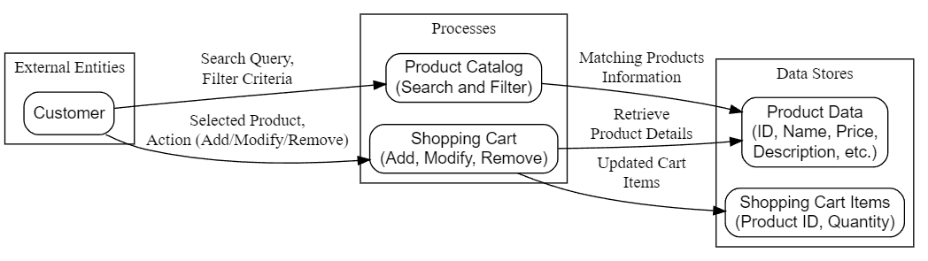

Figure 4: Sprint 3 DFD of Product Catalog and Shopping Cart Module

* **Activities**: Implementation of the product catalog with search and filtering capabilities is one of the activities. Help customers add, alter, and delete products from their shopping carts by developing the functionality of the shopping cart.
* **Key Deliverables:** The shopping cart system is operational, and the product catalog performs its functions.
* **Daily Meeting Focus:**
* *Update:* Millie provides an update on the development of the product portfolio. Peter discusses the functionality of the shopping cart. Anita will assist in integrating both components.
* *Challenges:* Address any complaints that users may have regarding the product catalog or any problems that may arise with the functionality of the shopping cart.
* *Next Steps:* Conduct user flow testing to ensure smooth catalog and cart integration. Pat is going to test and report back on any problems with the user experience.
* **Roles in the module:**
* **Millie:** To improve the overall user experience, Millie is responsible for developing search and filtering tools for the product catalog.
* **Peter:** Peter is responsible for working on the functionality of the shopping cart, which enables users to add, modify, and delete products.
* **Anita:** Assists in linking the product catalog with the shopping cart, guaranteeing that the user experience is uninterrupted.
* **Cheryl:** Cheryl ensures that the project remains on schedule by coordinating the work of the development and testing teams.
* **Pat:** Pat contributes to testing the shopping cart and product catalog modules, offering comments to make changes.

**Sprint 4:** **Checkout Process and Payment Module**

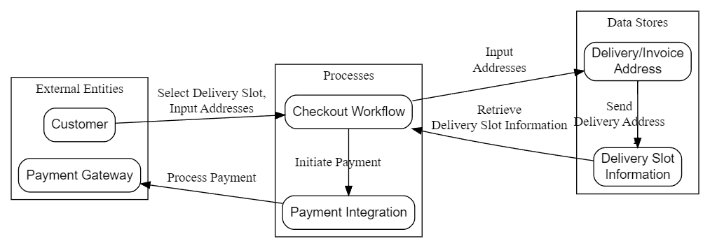

Figure 5: Sprint 4 DFD of Checkout Process and Payment Module

* **Activities**: The activities include the creation of the checkout workflow, which consists of selecting delivery slots and inputting delivery and invoicing addresses. If you want to manage transactions securely, integrate with payment gateways.
* **Key Deliverables:** Checkout capability and interaction with payment processing are two of the most critical deliverables
* **Daily Meeting Focus:**
* *Update:* Millie discusses the connectivity with payment gateways in response to the latest update. Peter designs the workflow for the checkout. Anita maintains a user-friendly interface.
* *Challenges:* Discuss any integration issues that may arise with payment gateways or complications that may arise with workflow.
* *Next Steps:* In the following steps, Peter and Anita will work to improve the checkout procedure. Pat examines the checkout and payment module to ensure it is secure and straightforward.
* **Roles in the module:**
* **Millie:** Millie is responsible for developing administrative solutions for order administration and tracking.
* **Peter:** Performs work on the backend systems to process orders.
* **Anita:** Anita assists in integrating the order management system with inventory management.
* **Cheryl:** Cheryl is leading the team and concentrating on whether or not the module can be integrated with the other components of the platform.
* **Pat:** Tests the order management module, identifies and fixes any potential problems that may arise, and focuses on Pat.

**Sprint 5: Order Management Module**

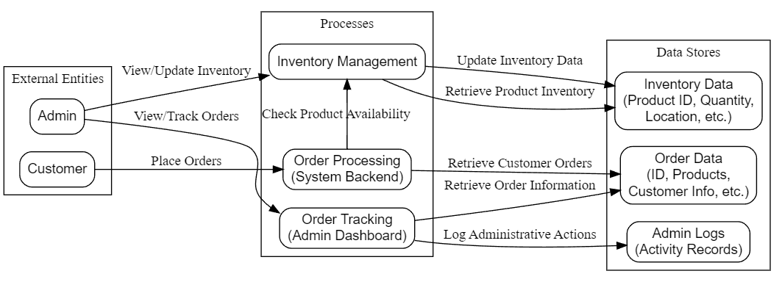

Figure 6: Sprint 5 DFD of Order Management Module

* **Activities**: To process orders, you should develop the backend system with administrative features for order tracking and management. Take measures to ensure that the inventory system is integrated.
* **Key Deliverables:** Order management system, integration with inventory management.
* **Daily Meeting Focus:**
* *Update:* Millie is responsible for developing backend technologies for order administration. Peter is responsible for the processing of orders. Anita integrates both the management of orders and inventories.
* *Challenges:* Identify any integration difficulties that may exist between the warehouse management system and the order management system.
* *Next Steps:* Integrated checks will be completed by Anita. The elements of order management are the primary focus of Pat's testing efforts.
* **Roles in the module:**
* **Millie:** Millie is responsible for integrating payment gateways and concentrating on managing secure transactions.
* **Peter:** Peter is responsible for designing the workflow for the checkout process, which includes the selection of delivery slots and the input of addresses.
* **Anita:** Anita is responsible for ensuring that the checkout procedure is easy to use and testing the connection with payment systems.
* **Cheryl:** Cheryl supervises the sprint, solves any problems that may arise, and ensures that the team achieves its objectives.
* **Pat:** Testing the order management module, finding and resolving potential problems.

**Sprint 6: Final Testing, Iteration, and Launch Prep**

* **Activities**: Activities include conducting extensive testing across all main functionalities, addressing any issues discovered, and continuously improving features based on feedback received. Make preparations for the platform launch, with a particular emphasis on deployment and operational preparedness.
* **Key Deliverables:** Principal Deliverables: MVP has been thoroughly tested and polished, and launch preparation has been finished.
* **Daily Meeting Focus:**
* *Update:* The members of the team have reported on the problems that were discovered during testing as well as the current state of feature polishing.
* *Challenges:* Notify the team of any serious issues or feedback items that could potentially cause the launch to be delayed.
* *Next Steps:* Pay attention to finding solutions to important problems. Pat oversees the final testing activities to ensure the MVP is ready for release.

## Merits of Using Agile Concepts

- There are various advantages to Green Groceries using System Concepts to create an online platform utilizing Agile concepts (Trailokya, 2023):

* **Flexibility and Responsiveness:** Green Groceries needs agile methodologies that allow frequent prioritization and rapid change response as they build a platform that meets customers' shifting needs and market trends. This versatility ensures the platform's competitiveness and relevance.
* **Customer and Stakeholder Engagement:** Agile promotes communication and collaboration with stakeholders, especially customers. Green Groceries may incorporate local farmers', eco-conscious suppliers', and end customers' feedback into development. This ensures that the platform meets market needs efficiently.
* **Project Visibility and Predictability:** Agile techniques allow Green Groceries to track progress and issues in real-time while developing their web platform. Transparency helps make informed decisions and modifications, which increases project predictability.
* **Quality Improvement:** Due to iterative development and regular testing, Agile principles help maintain quality by identifying and fixing issues early. For Green Groceries, the online platform will be reliable, secure, and user-friendly, improving the customer experience.
* **Customer Satisfaction:** Agile allows Green Groceries to quickly and continuously build working software to meet customer expectations. This dramatically improves consumer satisfaction and loyalty.
* **Team Morale and Productivity:** In the Green Groceries project, System Concepts' development team and Green Groceries' workforce are more likely to be motivated, productive, and dedicated to doing their best work.

**Effective Risk Management:** Agile reduces last-minute surprises and project failures by identifying and fixing issues early. This allows Green Groceries to better control online platform development risks, assuring a smoother launch and operation.

# Section B

# High-Level Requirement Analysis using MOSCOW rules

## B1. Baseline Requirement Review

### B1.1 -> Given Requirement Analysis using MOSCOW rules

|  |  |  |  |
| --- | --- | --- | --- |
| ID | Requirement List | Moscow Rules Applied | Reasons |
| 1 | As an Order Handling Clerk, I want to use the website to process telephone purchases, replacing the paper-based system. | Must Have | Essential for transitioning from paper-based to digital, improving efficiency and accuracy. |
| 2 | Maintain at least 20 office plants as part of the company's commitment to a green and healthy workspace. | Won't Have | It is not related to the online platform; it is more relevant to the physical office environment. |
| 3 | As a customer, I want to be able to change my account details to ensure my most up-to-date information is recorded. | Should Have | It is essential to ensure that user information is always up to date and to enhance the overall customer experience. |
| 4 | Organize a virtual celebration on the website for the CEO's birthday to showcase the company's fun and friendly culture. | Won't Have | It is more of a feature that is desirable to have rather than something necessary for the basic functionalities of the platform. |
| 5 | As the Managing Director I want to be ensured that the site is Data Protection Act safe so that we do not get fined hundreds of thousands of pounds. | Must Have | It is a legal duty to avoid fines and secure client data. |
| 6 | As a customer register an account. | Must Have | It is essential to facilitate the creation of tailored shopping experiences and facilitate order monitoring. |
| 7 | As a Customer I want a choice of delivery slots so that I can arrange my diary appropriately. | Should Have | It enhances customer service and order flexibility. |
| 8 | As a customer, I want to be able to modify my shopping cart so that I can change my mind about what I want to buy. | Must Have | It's crucial for flexible shopping. |
| 9 | The company should adopt pet-friendly policies to create a positive and inclusive work environment. | Won't Have | This has nothing to do with online platform development. |
| 10 | The system must be designed to handle a 30% increase in traffic during peak periods without degradation in performance. | Must Have | Ensure performance and quality of service during high traffic. |
| 11 | As a customer, I want to enter separate delivery and invoice addresses so that I can receive bags when staying at a friend’s house. | Should Have | Customers benefit from increased convenience, which positively impacts their overall satisfaction. |
| 12 | As a Customer I want to be able to change my account details so that my most up to date details are recorded. | DUPLICATED | Duplicated Requirement ( with requirement ID: 3.) |
| 13 | `As an Order Handling Clerk I want to use the Web site to process telephone purchases so that I can stop using the paper-based system. | DUPLICATED | Duplicated Requirement ( with requirement ID: 1.) |
| 14 | As a customer, I want to choose whether or not I am sent marketing information to avoid receiving excessive junk mail. | Could Have | User privacy will be improved, and unsolicited communications will be reduced. |
| 15 | All user data, including personal information and payment details, must be encrypted to ensure the highest level of security. | Must Have | Necessary for data security and compliance. |
| 16 | Maintain consistent branding elements and design across the website to reinforce their brand identity. | Should Have | It is vital for marketing and user experience but not platform functionality. |
| 17 | The development team should participate in a team-building event every quarter to foster collaboration and a positive work environment. | Won't Have | It improves team morale but doesn't meet platform requirements. |
| 18 | As the Marketing Director I would like an offers or discount page so that we can inform our customers of the aforementioned. | Should Have | The platform needs it for marketing and sales rather than for basic functions. |
| 19 | As the Chief Accountant I want to the Web site to adhere to legislation regarding VAT so we are not hit with a hefty fine. | Must Have | It is a legal duty to avoid fines and secure client data. |
| 20 | As the Operations Director, I want to accept all forms of payment to capture the largest market possible. | Must Have | Important for sales and customer satisfaction. |

### B1.2 -> Updated High-Level Requirements

|  |  |  |
| --- | --- | --- |
| ID | High-Level Functional Requirement | Justifications/Recommendations |
| 1 | As an Order Handling Clerk, I use the website to process telephone purchases. | It is improving efficiency. |
| 5 | Ensure the site is Data Protection Act compliant to avoid fines. | The legal requirement for client data security. |
| 6 | Allow customers to register an account. | It provides the ability to track orders and provide individualized shopping experiences. |
| 8 | Enable customers to modify their shopping cart. | Crucial for flexible shopping experiences. |
| 10 | Design the system to handle a 30% increase in traffic during peak periods. | Ensures performance and service quality during high traffic. |
| 15 | Encrypt all user data, including personal and payment details. | Necessary for data security and compliance. |
| 19 | Ensure the website adheres to VAT legislation to avoid fines. | Legal requirements are to secure client data and avoid fines. |
| 14 | Customers should be given the option to decide whether or not they want to receive marketing information. | Improves user privacy and reduces unsolicited communications. |
| 18 | For marketing, include a page that contains offers or discounts. | Required to market products and services and to tell clients about deals and discounts. |
| 20 | Any form of payment should be accepted. | It is important for sales and customer satisfaction. |

## B2. Timebox Rules for the Updated High-Level Functional Requirements

### B2.1 -> Prioritization for the List of Requirements (ADD ROLE INCHARGE)

|  |  |  |  |
| --- | --- | --- | --- |
| ID | Updated High-Level Functional Requirement | Priority Levels | Time scale |
| 1 | As an Order Handling Clerk, I use the website to process telephone purchases. | **High** | 1 month |
| 5 | Ensure the site is Data Protection Act compliant to avoid fines. | **High** | 1 month |
| 6 | Allow customers to register an account. | **Moderate** | 1.5 month |
| 8 | Enable customers to modify their shopping cart. | **High** | 1 month |
| 10 | Design the system to handle a 30% increase in traffic during peak periods. | **High** | 1.5 months |
| 15 | Encrypt all user data, including personal and payment details. | **High** | 1 month |
| 19 | Ensure the website adheres to VAT legislation to avoid fines. | **High** | 1 month |
| 14 | Customers should be given the option to decide whether or not they want to receive marketing information. | **Low** | 2 months |
| 18 | For marketing, include a page that contains offers or discounts. | **Moderate** | 1.5 months |
| 20 | Any form of payment should be accepted. | **Moderate** | 2 months |

### B2.2 -> Explanation about Prioritizing the Requirements and the Decisions taken to the Green Groceries Online Platform

- Throughout the development of the Green Groceries Online Platform, a methodical approach to prioritizing requirements was utilized. This approach was driven by the notion of delivering maximum value within the constraints of the timetable. The High, Moderate, and Low-priority classifications were the foundation for this approach. Each category can be interpreted as a strategic indicator of the requirement's significance to the project's accomplishment. Implementing this organized priority guarantees a concentrated deployment of resources and assures that the development efforts align with the platform's fundamental goals. A discussion further explains how these priority levels were assigned to the various needs, indicating the relative importance of these requirements and the reasoning that led to these decisions.

* **High Priority Requirements**
* **ID 1 (High):** Swift action must be taken to process telephone purchases, essential for operational efficiency and customer service.
* **ID 5 (High):** Legal and security concerns make it impossible to compromise the necessity of ensuring compliance with the Data Protection Act.
* **ID 8 (High):** Making it possible for customers to change their shopping carts is vital to a flexible shopping experience.
* **ID 10 (High):** The platform's dependability and scalability under load can be ensured by considering increased traffic when designing it.
* **ID 15 (High):** Implementation of encryption of user data must be done as soon as possible because it is essential for both privacy and compliance.
* **ID 19 (High):** It is a legal need to comply with VAT legislation to avoid incurring fines and to guarantee compliance.
* **Moderate Priority Requirements**
* **ID 6 (Moderate):** The user experience can be improved by allowing customers to register for accounts, but this practice is not immediately essential.
* **ID 18 (Moderate):** While it is essential for marketing to include a page with offers or discounts, this can be done after the basic core development has been completed.
* **ID 20 (Moderate):** Accepting all means of payment is essential for the customer's convenience, but it can be expanded after the product's launch.
* **Low Priority:**
* **ID 14 (Low):** Compared to the needs for basic functionalities and compliance, providing clients with the choice to opt out of marketing is a less pressing matter, but it improves user satisfaction.

# Section - C

# Legal, Social, Ethical, and Professional Issues

## C1. Legal, Social, Ethical, and Professional Issues (LSEPI)

- Within the constantly changing realm of online business operations and technological advancements, businesses such as Green Groceries encounter a complex web of Legal, Social, Ethical, and Professional Issues (LSEPI). Carefully and proactively managing these challenges is the highest priority to ensure adherence to legal requirements and cultivate confidence, esteem, and allegiance among clientele, staff, and the wider society. These principles must be incorporated into the strategic planning and daily operations of Green Groceries' online platform initiative to ensure its success.

* **Legal Issues:**
* A wide range of regulations, including those about consumer rights and e-commerce and data protection and privacy, are included in legal issues. Because of the digital character of the online platform project, primary legal considerations must be considered, notably the protection of user data.
* *Case Study Example:* **Apple's iOS 14 Privacy Update** (Newman, 2020)
* **Background:** iOS 14, released by Apple in September 2020, introduced significant privacy features that revolutionized user data collection with its introduction. A substantial shift from the opt-out data collection models that were previously in place, one of its highlights was the requirement that applications must first obtain users' explicit approval before gathering information about their actions.
* **Challenge:** There was the possibility of a disruption in the digital advertising industry, primarily dependent on user data for creating targeted advertisements. Companies like Facebook have voiced their concerns, noting the significant impact this move would have on their advertising revenue and the broader ecosystem dependent on such data.
* **Action:** Apple has adopted many privacy features, such as comprehensive tracking reports in Safari, security "nutrition labels" for applications in the App Store, notifications for password breaches, and several other features. The introduction of an opt-in method for data tracking was a significant update that brought about a fundamental change in how user consent is gained for data collecting.
* **Outcome:** Apple's implementation of these privacy safeguards has significantly impacted the digital economy, which has led to increased consumer knowledge and control over personal data. As a result of this push, many businesses have revised their data gathering and privacy procedures to accommodate their customers' increased scrutiny and expectations. As a consequence of this, the privacy upgrade that Apple released for iOS 14 is considered to be a watershed event in the legal and ethical concerns that surround digital privacy. It has established new standards affecting worldwide data protection policies and industry practices for many years.
* **Social** **Issues:**
* As an indication of the company's dedication to societal values and the community's well-being, social issues are equally important. Among these are promoting environmentally sustainable practices, assisting local communities, and guaranteeing that the internet platform is accessible to people experiencing impairments. A warm and welcoming atmosphere can be fostered by incorporating social values into the organization's culture.
* *Case Study Example:* **LinkedIn’s Diversity, Inclusion, and Belonging Initiatives** (LinkedIn News, 2021)
* **Background:** In 2021, LinkedIn introduced some initiatives to encourage diversity, inclusiveness, and a sense of belonging across its platform and workforce. These efforts were launched in response to growing calls for more inclusive workplaces.
* **Challenge:** The IT sector has been criticized for lacking diversity and inclusion, which affects various aspects, including employment procedures and product development.
* **Action:** LinkedIn made free learning resources on diversity and inclusion available. The company also improved its hiring tools to decrease bias and is committed to transparently reporting on its workforce diversity efforts.
* **Outcome:** Through implementing these efforts, the technology industry has been able to engage in a more comprehensive conversation and take action in this direction. LinkedIn has made progress in increasing its personnel's diversity and enhancing its platform's inclusiveness.
* **Ethical Issues:**
* Concerns related to ethics concentrate upon the concepts of justice, transparency, and consideration for the rights of individuals. These concerns are particularly significant regarding how the business maintains its customers' interactions and data.
* *Case Study Example:* **Zoom’s Encryption Overhaul** (Statt, 2020)
* **Background:** Zoom was criticized in 2020 for making promises of end-to-end encryption that did not reach the required level. These assertions raised substantial ethical problems regarding the privacy of users and the security of their data.
* **Challenge:** The security and privacy of video conferencing software came under great examination due to the COVID-19 epidemic, which caused an increase in the number of people working remotely and communicating with one another.
* **Action:** All users will now have access to end-to-end encryption, announced by Zoom as a significant enhancement to its encryption system. This update addresses the ethical issues associated with user privacy and security.
* **Outcome:** Through this action, Zoom's safety features were greatly strengthened, restoring customers' faith in the platform and establishing a new benchmark for privacy in video conferencing platforms.
* **Professional Issues:**
* Contributing to the profession's growth, sharing one's knowledge, and providing help to other professionals are all aspects of dedication to the profession. Within the framework of the Green Groceries online platform project, professionalism includes compliance with industry standards, the pursuit of continual learning, and dedication to quality and excellence.
* *Case Study Example:* **GitHub Archive Program** (Metcalf, 2020)
* **Background:** By implementing the GitHub Archive Programme in 2020, the company aims to preserve open-source software by storing it in an Arctic code vault for future generations.
* **Challenge:** Even while the preservation of this digital history poses its own set of challenges, the sustainability and longevity of open-source projects are essential for the growth of technology in the future.
* **Action:** By physically storing code in a secure vault in the Arctic, GitHub has taken an innovative approach to preserving data. This ensures that the code will endure for centuries after centuries.
* **Outcome:** To safeguard the collective technological knowledge and to contribute to the professional evolution of the software development sector, the program has been praised as an important step that has been taken.

## C2. Purpose of a Professional Body and the BCS Code of Conduct

- The British Computer Society (BCS) is an organization that plays a crucial role in developing, promoting, and governing standards within particular industries. In addition to ensuring that members adhere to a high standard of professionalism and ethical behavior, their primary objective is to promote expanding knowledge and ethical standards among professionals. Professional organizations also play an essential part in providing a platform for opportunities to engage in ongoing learning and professional development, as well as networking among professionals.

- As the Chartered Institute for Information Technology, BCS has a thorough Code of Conduct to guide its members in their professional endeavors. Upholding this code is necessary to preserve the honor and reputation of the profession. It comprises four primary sections: duty to the profession, duty to the relevant authority, the public interest, and professional competence and integrity. (University of Cape Town, n.d.)

* **The Public Interest:**
* A significant part of the development of policies, practices, and ethics geared towards serving society's general welfare and well-being is played by public interest, particularly in information technology and related fields. Frequently, the concept of the public interest ensures that actions, decisions, and policies contribute to the common good while also striking a balance between the rights of individuals and the community's requirements.
* *Practical Example:* To pursue public interest in information technology and related sectors, it is frequently necessary to address ethical concerns, encourage whistleblowers, and guarantee transparency and accountability (Transparency International, n.d.). An individual named Dmitry Ershov, who works as a project manager for the United Nations Development Programme (UNDP) in Russia, expressed his worries regarding the misuse of money that was supposed to be used for environmental projects. His activities highlighted the significance of whistleblower mechanisms in protecting funding for climate and environmental protection, even though he was fired and did not receive help from the UNDP. In light of this case, it is clear that whistleblowers play an essential part in bringing to light instances of unethical behavior in the financial sector and that they require robust protection measures. (Cadwalladr & Graham-Harrison, 2018)
* **Duty to Relevant Authority**
* Professionals in information technology have a duty to relevant authority, which includes commitments to their employers, customers, and end-users. This obligation requires the task to be completed to the appropriate standard, and practitioners must refrain from using their position exclusively for their benefit.
* *Practical Example:* Cambridge Analytica, a consulting business, successfully obtained unauthorized access to the personal data of millions of Facebook users in 2018, which allowed them to use this information for political profiling purposes. This breach brought to light the significance of information technology professionals fulfilling their obligations to relevant authorities, such as customers and users, by ensuring that data security measures are in place and that compliance with applicable regulations, such as the General Data Protection Regulation (GDPR) or the California Consumer Privacy Act (CCPA), is maintained. Information technology professionals' commitment to their customers and users is fulfilled when they make the correct treatment and protection of sensitive data their top priority. This protects the users' privacy and prevents the exploitation of personal information for purposes that are not authorized.
* **Duty to the Profession**
* Duty to the profession means supporting other members and upholding the profession; for example, assisting junior members in their professional development. To fulfill this ethical commitment, one must actively contribute to their professional sector's individual and collective progress while maintaining integrity. Professionals are tasked with cultivating an atmosphere favorable and conducive to the growth of information sharing, mentoring, and collaboration.
* *Practical Example:* Stack Overflow is an excellent example of an entity that helps fulfill the responsibility of a professional developer to the profession by maintaining its integrity and providing help to its members. This includes assisting junior developers in their professional development. Because it is structured in a question-and-answer session, it makes it easier for professionals to share their knowledge and promotes educational experiences for younger and senior members. Senior members frequently provide mentorship through instruction and criticism, and the platform's substantial documentation and code review features benefit the development of skills. Stack Overflow is a prime example of the dedication to preserving the profession and cultivating its members since it creates an atmosphere that encourages collaboration and provides professionals with opportunities to participate, learn, and develop. (Yuhao et al., 2019)
* **Professional Competence and Integrity**
* The ability of individuals or organizations to carry out their responsibilities in the field of information technology effectively and efficiently is what professional competence means in the context of information technology. One example is having the knowledge, abilities, and competence required to carry out activities, find solutions to problems, and deliver high-quality outputs by industry standards and best practices. To ensure that one's work remains relevant and proficient, keeping up with the most recent advancements, technologies, and techniques pertinent to the information technology area is also necessary. Ethical behavior, honesty, and consistency in both actions and decisions are all components of integrity. In addition to servicing customers, employers, and other stakeholders, it is necessary to maintain high moral and ethical standards, safeguard secrecy, and secure confidentiality. To be considered an IT professional with integrity, one must be up-to-date in their sector and commit to continuous learning, improvement, and transparency. It is necessary to actively pursue education, training, and skill development to stay up with the ever-evolving technology, trends in the industry, and regulatory requirements to preserve stakeholders' trust in the information technology profession.
* *Practical Example:* Microsoft's strategic business processes and organizational environment are evidence of the company's dedication to maintaining professional competence and integrity, particularly in maintaining knowledge and expertise. During CEO Satya Nadella's transformation, the company has deftly shifted its focus to emerging technical trends, such as cloud computing, through its Azure platform. This demonstrates the company's agility and preparedness to adapt to a field that is undergoing rapid change. According to Microsoft, this strategic pivot is supported by the company's continual innovation and refinement of its essential products, such as Windows and Office, to meet current consumers' demands and maintain its relevance in the digital technology industry. Additionally, Microsoft has expanded into new technologies, such as the Intelligent Cloud and More Personal Computing technology, to broaden its expertise. The company's dedication to professional competence is demonstrated by its ability to persevere in the face of intense competition and by maintaining a culture that encourages and values the creative contributions of its employees. Microsoft retains its knowledge and experience up to date in the rapidly evolving world of technology by fostering a culture of constant learning and flexibility. This allows the company to reinforce its strengths and acquire new talents. (Investopedia, 2014)

# Conclusion and Assumptions

- The report on the management of requirements for Green Groceries' online platform provides an overview of the critical role that Agile approaches play in overcoming the problems associated with traditional development. The project embraces flexibility and adaptation and ensures that the development process is centered on the client by incorporating Agile principles such as Scrum, Timeboxing, and DSDM. This technique has been immensely helpful in meeting the ever-changing requirements of Green Groceries since it enables rapid iteration and continual feedback integration through its implementation. Using the MoSCoW technique to prioritize requirements allows the project to allocate resources effectively to essential capabilities. This helps to ensure that the platform is sturdy, that users are satisfied, and that it operates efficiently. The focus that the Agile framework places on collaboration and stakeholder interaction further increases the project's compatibility with the objective of Green Groceries, which is to promote accessibility and sustainability in the online grocery industry.

- The project is subject to some fundamental assumptions. First, it assumes that the Agile approaches chosen are the most appropriate for the project's requirements and the stakeholders' dynamics. Second, the prioritization of development tasks requires an accurate reflection of the strategic goals of the project as well as the available resources. Additionally, it is anticipated that the development team is proficient in Agile methods and that all stakeholders are committed to active engagement in the iterative development process. Finally, the project assumes that external factors, such as market trends and technological advancements, would continue to be stable enough to prevent the need for significant strategic revisions during the development cycle. These assumptions are essential for ensuring that the project continues on its path toward delivering a responsive and high-quality online platform for Green Groceries.

# REFERENCES

1. *Trailokya, O., 2023. Critical Success Factors of Agile Software Development - A Systematic Literature Review*. Available at: <https://www.researchgate.net/publication/376507291_Critical_Success_Factors_of_Agile_Software_Development_-_A_Systematic_Literature_Review/link/659393282468df72d3f0dc98/download> [Accessed 07 March 2024].
2. *Meyer, E.T.T. (no date) (PDF) Social, Ethical, and Legal Issues in Presence Research and Applications*. Available at: <https://www.researchgate.net/publication/228243828_Social_Ethical_and_Legal_Issues_in_Presence_Research_and_Applications> [Accessed 07 March 2024].
3. *Newman, D., 2020. Apple’s iOS 14 Privacy Update Changes The Complexion Of User Data Collection. Forbes*. Available at: <https://www.forbes.com/sites/danielnewman/2020/09/30/apples-ios-14-privacy-update-changes-the-complexion-of-user-data-collection/?sh=3b8700dfed9e> [Accessed 08 March 2024].
4. *LinkedIn News, 2021. 2021 Workforce Diversity Report*. Available at: <https://news.linkedin.com/2021/october/2021-workforce-diversity-report> [Accessed 08 March 2024].
5. *Statt, N. (2020) Zoom says free users will get end-to-end encryption after all, The Verge.* Available at: <https://www.theverge.com/2020/6/17/21294355/zoom-end-to-end-encryption-security-privacy> [Accessed 08 March 2024].
6. *Metcalf, J. (2020) GitHub Archive Program: The journey of the world’s open source code to the Arctic, The GitHub Blog*. Available at: <https://github.blog/2020-07-16-github-archive-program-the-journey-of-the-worlds-open-source-code-to-the-arctic> [Accessed 15 March 2024].
7. *University of Cape Town, No date. Professional and Ethical Issues.* Available at: <https://www.cs.uct.ac.za/mit_notes/ethics/htmls/ch04s04.html> [Accessed 15 March 2024].
8. *Transparency International, No date. Whistleblowers: Vital role in climate protection.* Available at:<https://www.transparency.org/en/projects/climate-governance-integrity-programme/climate-corruption-atlas/whistleblowers-vital-role-in-climate-protection> [Accessed 16 March 2024].
9. *Cadwalladr, C., Graham-Harrison, E., 2018. Revealed: 50 million Facebook profiles harvested for Cambridge Analytica in major data breach.* The Guardian. Available at: <https://www.theguardian.com/news/2018/mar/17/cambridge-analytica-facebook-influence-us-election> [Accessed 16 March 2024].
10. *Yuhao W., Wang S., Bezemer, Inoue K., 2019. How Do Developers Utilize Source Code from Stack Overflow?*.Available at: <https://www.researchgate.net/publication/324951594_How_Do_Developers_Utilize_Source_Code_from_Stack_Overflow> [Accessed 28 March 2024].
11. *Investopedia, 2014. The Real Secret to Microsoft's Success*. Available at: <https://www.investopedia.com/stock-analysis/032014/real-secret-microsofts-success-msft-aapl-goog-ibm.aspx> [Accessed 28 March 2024].

**ABOUT THE IMPLEMENT OF AI NOTE**

*\* This report document has some assistance from CHAT GPT in looking up suitable reference sources and suggesting logical academic documentation structure; Grammarly in correcting grammatical errors\**